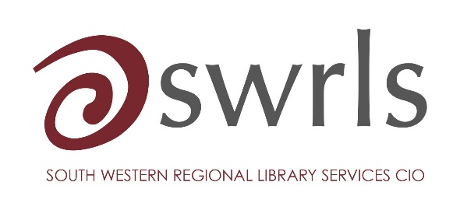 | Claim Form for Travel  & Expenses

NAME OF CLAIMANT
DETAILS for BACS transfer: |  |  |  | Account name:  Account no:  Sort code:
DATE |  | DETAILS OF CLAIM (e.g. start and end point of journey) |  |  | NO. OF MILES | AMOUNT @ 45p PER MILE £ | OTHER EXPENSES (Parking / Rail / Bus fares etc)  £
 |  | TOTALS
TOTAL CLAIM | £

I HEREBY CERTIFY THAT THE INFORMATION CONTAINED ON THIS FORM IS CORRECT:

SIGNATURE OF CLAIMANT:
DATE:

AUTHORISED BY:
DATE:

Please send receipts along with this form to:
KKellaway@marjon.ac.uk with “SWRLS Expenses Claim” as the subject line.

